1. Open **Photoshop**
2. Go to **File** and select **New**.
3. We will create 40 x 40 pixel images in this example. Copy the settings into you **New** dialog box changing only the **Width** and **Height**. Also **Name** your project something. This will not be the name of your final images, but the name of your Photoshop project.

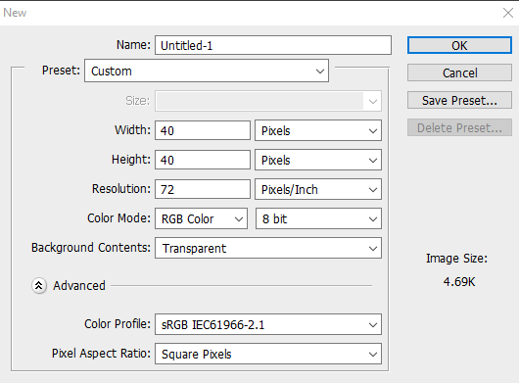

1. Go to **View** then **Show** then turn on **Grid**. When **Grid** is turned a check will be to the left of the option **Grid** in the **View** menu.

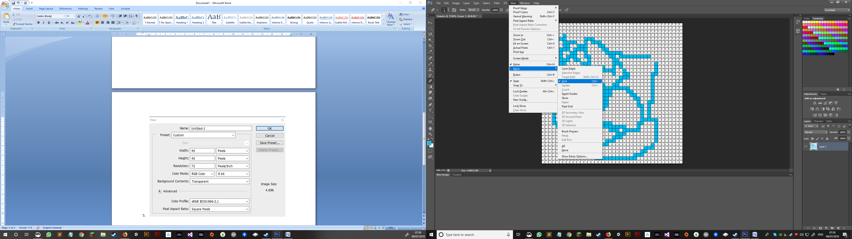

1. Go to **View** then **Show** then turn on **Pixel Grid**. When **Pixel Grid** is turned a check will be to the left of the option **Pixel Grid** in the **View** menu.

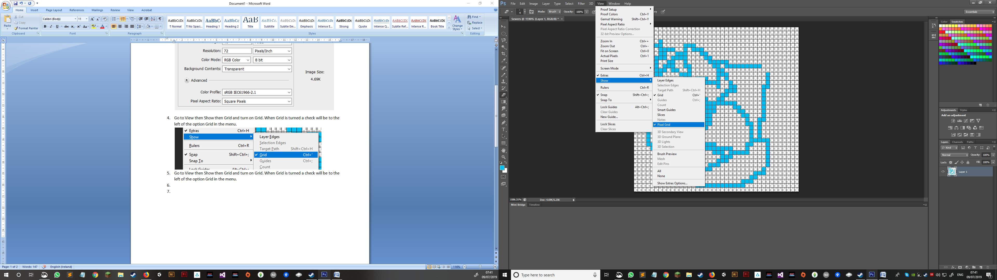

1. Ensure that the **Gridline Every:** setting is set in **Preferences**. Go to **Edit** in the menu then select **Preferences** and select **Guides, Grid & Slices**.

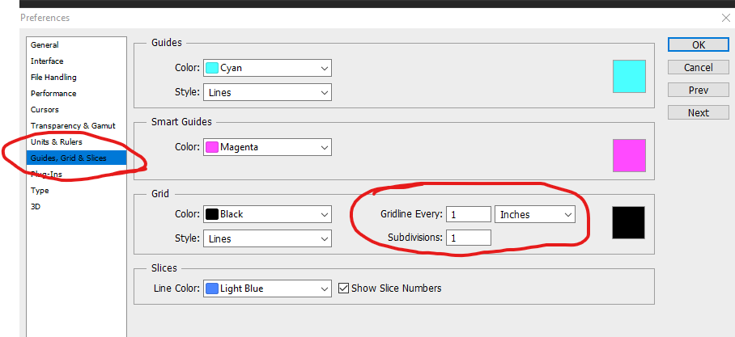

Ensure that there is a grid line ever 1 pixel! Also ensure that **Subdivisions** are set to 1.



1. Go to **Edit** in the menu then select **Preferences** and select General. Here we will see under Image Interpolation: that *Bicubic Automatic* is set. 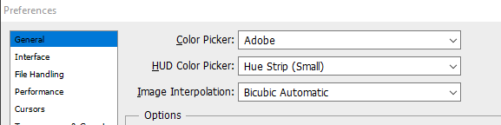

What is happening here is that Bicubic Automatic is set to attempt to smooth out lines. However, in pixel art, we want hard lines that are not smoothed out so we will select “**Nearest Neighbour**”

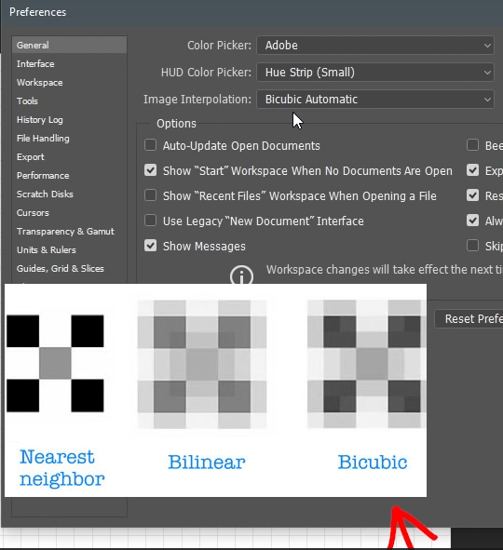

So what you see in the image below is the finished result.

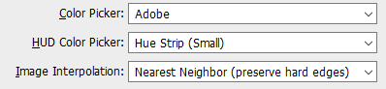

1. Right click anywhere on the canvas when you are in the Pencil tool and the following menu will open up:

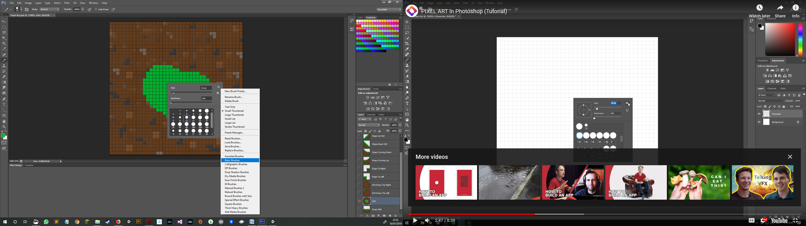

Select **Basic Brushes** and a dialog will open asking if you want to replace the current brushes with **Basic Brushes**, but you do want this so agree to the question. This will make all of the brushed suitable for Pixel Art.

1. In pixel painting one does not use the **Brush tool**. If you use the **Brush tool** images that you are working will have color bleeding across pixels like in the image below:

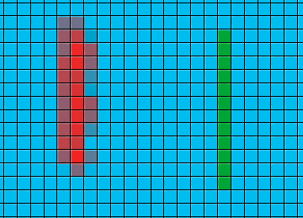

Here we have red and green pixels. The red is coloured with the **Brush tool** but notice how the color bleeds into the cell beside it. Such is the nature of the **Brush tool**. See now how green strip is contained in its own pixel every time. That is because I used the **Pencil tool**.

Ensure that the **Pencil tool** is selected from the **Tool menu**. In my setup the tool menu is docked to the left of the window. If the **Tool menu** cannot be seen, ensure that it is turned on by going to Window and selecting Tool or going to Window and ensuring that there is a tick beside the Tool option.

1. In the case of the 40 pixels x 40 pixels that I have selected I have created a template that marcs out the middles and corners of the block so that if I want to create patterns that match up I am able to do so with relative ease.

|  |  |  |
| --- | --- | --- |
|  |  |  |
| **This is a 40 x 40 pixel drawing with the guide line on, notice how I am able to clearly see the middle of the block.** | **This is the guide block alone. This is the top most later, and locked so that I cannot over write it.** | **This is the finished result.** |

1. Create as many tiles as are needed and when you are ready make a new Photoshop document. Have the new document file be divisible by the width of the tiles you have created, so if like the grass tile above your tile is 40 pixels square make your new canvas 400 pixels square so that the tiles can fit perfectly. Save this when all the images are on it and guess what we have a tilemap!!
2. Open **Unity** and place the tilemap in your assets folder (Follow this tutorial if you are stuck <https://www.youtube.com/watch?v=ryISV_nH8qw>).
3. First we need to create a tilemap. To do this right click in the **Hierarchy** in your **Unity** project and select **2D Object** then select **Tilemap.** This will create an object called a **Grid** for you. All tilemaps in Unity are rendered using a **Grid**.

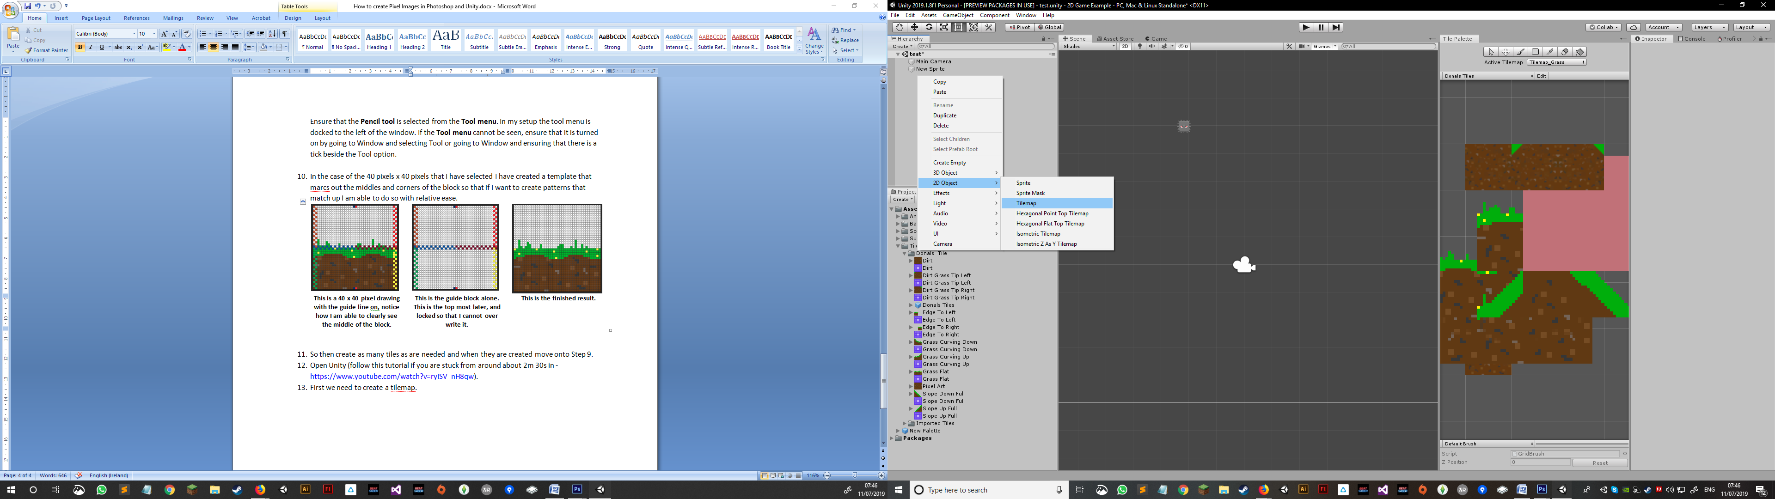

1. Next open up the **Tile Palette** window. Go to **Window**, go down to **2D** and select **Tile Palette** to view the **Tile Palette** window.

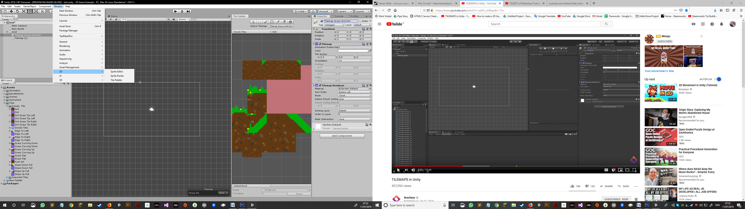

Hints & Tips:

* Photoshop version used in this example is *Adobe Photoshop CS 6*
* Ctrl + A : Selects Everything
* Ctrl + D : Deselects
* Ctrl + Z : Undo last action
* Ctrl + Atl + Z : Undo undo undo undo as many times as you press it